DIS-AM,C-TAINO-Cohoba Spoon

4 5/8 in. long, manatee bone

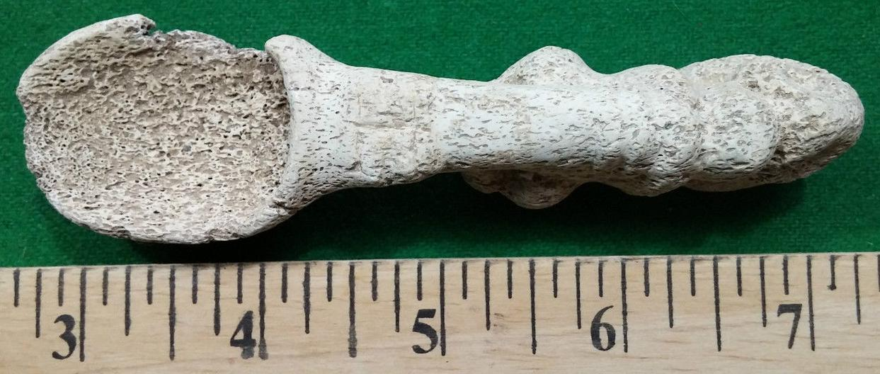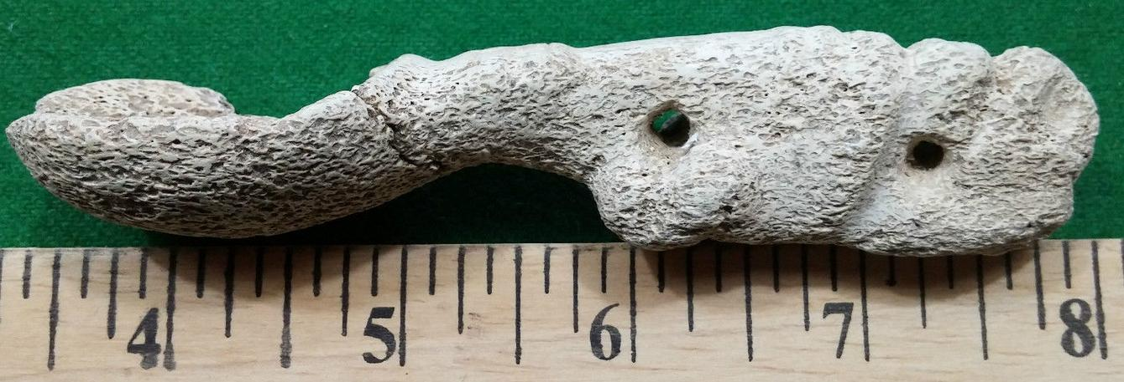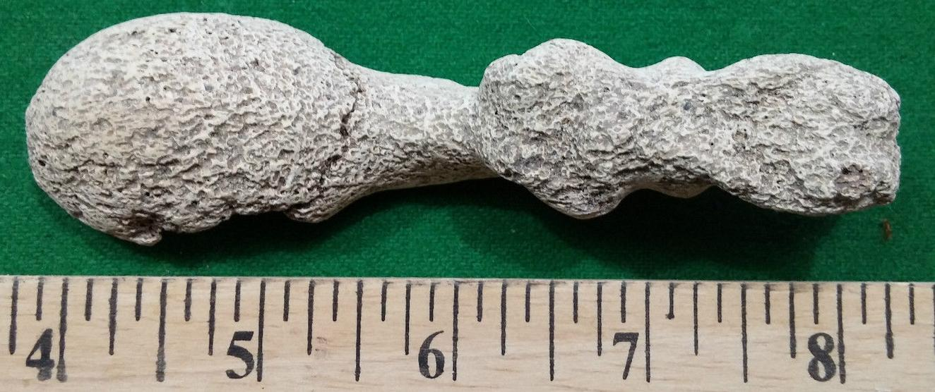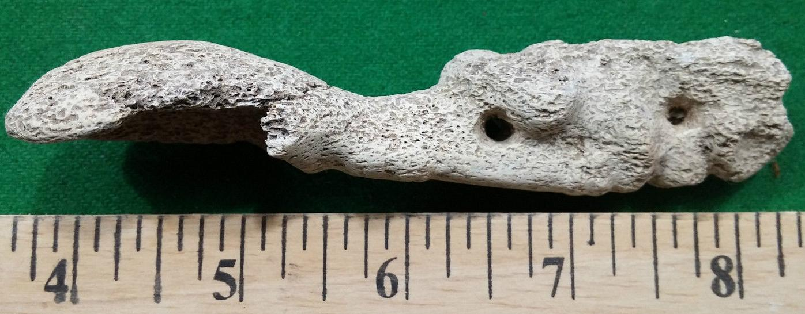

# Order details

## Sales order

Sold by [user1billion](http://myworld.ebay.com/user1billion) ( [780](http://feedback.ebay.com/ws/eBayISAPI.dll?ViewFeedback&userid=user1billion) )

### Delivery package 1 of 1

Estimated delivery Thursday, Jan 14, 2016 - Thursday, Jan 21, 2016

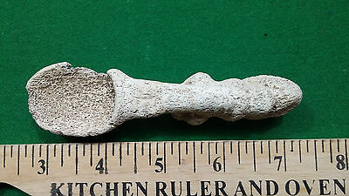

#### [Taino carved Cohoba Spoon Very Old - Pre Columbian](http://www.ebay.com/itm/161930266482)

|  |  |
| --- | --- |
| Item price | $79.99 |
| Quantity | 1 |
| Item number | 161930266482 |
| Shipping service | Standard Int'l Shipping |

## Shipping address

Ralph J Coffman Jr

149 Atlantic Ave

Swampscott MA 01907-2427

United States

## Order total

|  |  |
| --- | --- |
| Subtotal | $96.98 |
| Shipping | $26.70 |

**Total**

$123.68